**WILFRED GITHUKA BIT/2019/44664**

PROBABILITY AND STATISTICS I BMA1104

ASSIGNMENT CAT1 & 2

1. The time taken by a number of scientist to complete a certain job is normally distributed with a mean of 150 minutes and a standard deviation of 30 minutes.
2. What is the probability that a randomly selected scientist will take more than 210 minutes to complete the job?

Time taken = 150min

Std Dev 30 mins

P(210min) =

1. Calculate the probability that the selected scientist takes more than 90 minutes
2. A survey of enrollment at 35 community colleges across the United States yielded the following figures:

6414; 1550; 2109; 9350; 21828; 4300; 5944; 5722; 2825; 2044; 5481; 5200; 5853; 2750; 10012; 6357; 27000; 9414; 7681; 3200; 17500; 9200; 7380; 18314; 6557; 13713; 17768; 7493; 2771; 2861; 1263; 7285; 28165; 5080; 11622

1. Organize the data into a chart with five intervals of equal width. Label the two columns “Enrollment” and “Frequency.”
2. Construct a histogram of the data.
3. If you were to build a new community college, which piece of information would be more valuable: the mode or the mean? Mean
4. Calculate the sample mean. = 8,485
5. Calculate the sample standard deviation. = 6,721.85
6. A school with an enrollment of 8000 would be how many standard deviations away from the mean? = -0.09

**Solution:**

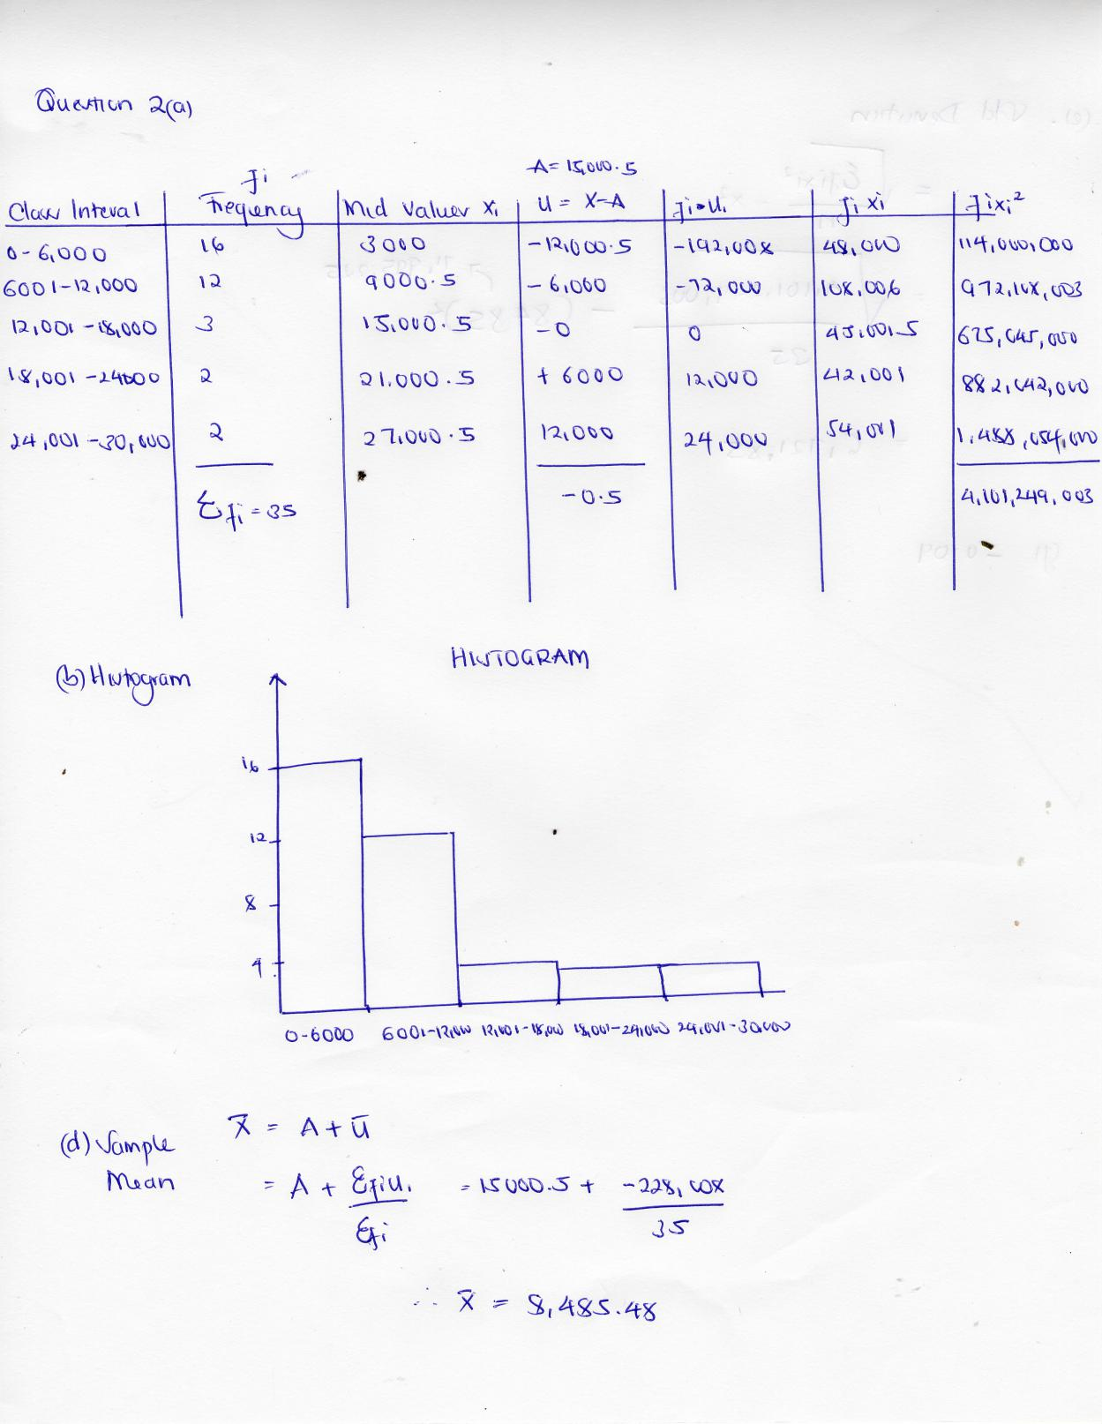

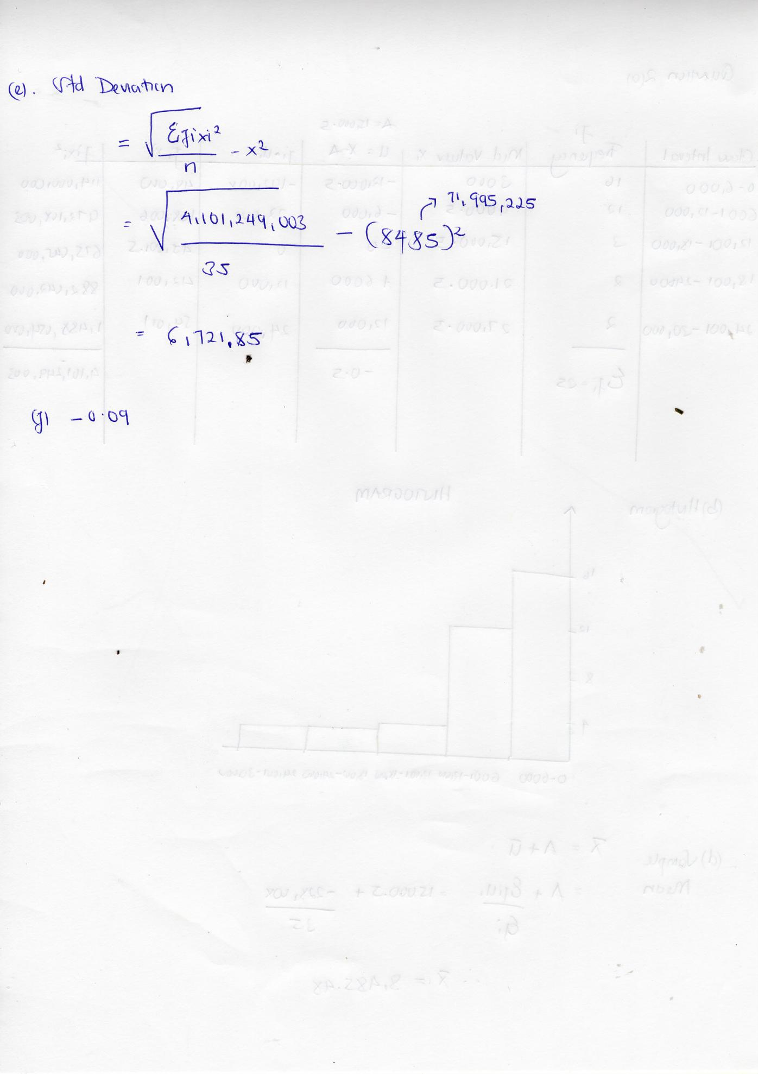

1. The probabilities of events A and B are

, , . Find in terms of 

1. 
2. 
3. Find the value of  given that A and B are independent events.

1. At a certain airport, 80% of the flights arrive on time. A sample of 10 flights is studied. Let be the number of flights that arrive on time. Find
2. 
3. 

P(X = 8) = (10/ 8) (0.75)8(.25) 2 = 0.2816

binompdf(10,0.75,8) = 0.2816

1. 

P(X ≥ 8) = 0.2816 + 10 9 (0.75)9 (0.25) + (0.75)10 = 0.5256 1‐binomcdf(10,0.75,7)=0.5256

1. 

P(Y ≤ 2) = P(X ≥ 8) = 0.5256 binomcdf (10,0.25, 2) = 0.5256 P(Y ≤ 2) = (0.75) 10 + 10 1 (.75) 9 (0.25) + 10 2⎟ (0.75) 8 (0.25) 2 = 0.5256

1. A random variable has the following probability distribution

|  |  |  |  |  |  |  |  |  |
| --- | --- | --- | --- | --- | --- | --- | --- | --- |
|  | 0 | 1 | 2 | 3 | 4 | 5 | 6 | 7 |
|  |  |  |  |  |  |  |  |  |

Find the following

1. The value of 

As we know, for any probablity distribution,

∑P(X)=1

So, for given distribution,

0+k+2k+2k+3k+k2+2k2+7k2+k=1

10k2+9k−1=0

10k2+10k−k−1=0

10k(k+1)−1(k+1)=0

(10k−1)(k+1)=0

As, k can not be negative, therefore our k=110

1. 

P(X>6)=P(X=7)

=7k2+k=7100+110=17100

1. and 